***Directions:*** Complete the Questions below (10 points each). Display a snippet of the code and the output below:

**COP2335: Object-Oriented Programming Lab 10**

43)

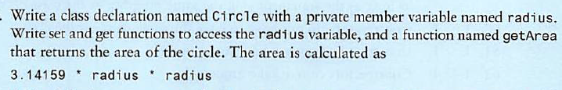**Snippet of the Classes:**

**Snippet of the Output:**

44)



**Snippet of the Classes:**

**Snippet of the Output:**

45)



**Snippet of the Classes:**

**Snippet of the Output:**

46)



**Snippet of the Classes:**

**Snippet of the Output:**

47)



**Snippet of the Classes:**

**Snippet of the Output:**

48)



**Snippet of the Classes:**

**Snippet of the Output:**

